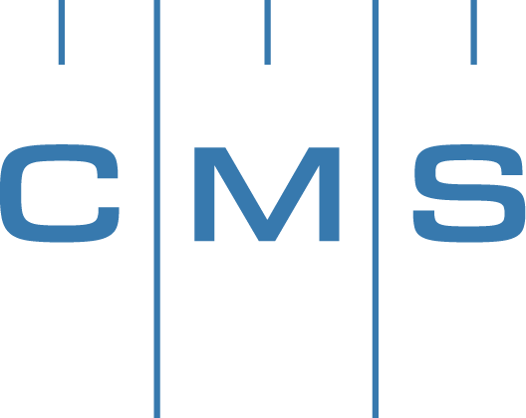
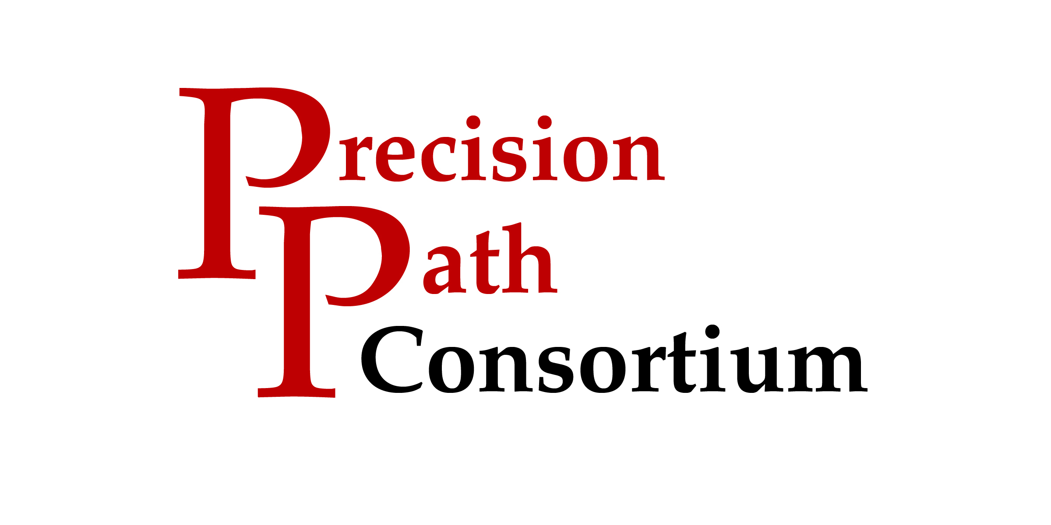

PRESS RELEASE | Press Contact: Belinda Jones, HiTech Marketing  860-399-1147, belinda.jones@hitechmarketing.com

PrecisionPath Consortium for Large-Scale Manufacturing Launches Industry-at-Large Survey on Monday, May 23
Industry-driven Consortium Invites Users and Managers of Portable Metrology Systems to Participate in Study

Weatherford, TX – May 23, 2016 – The Coordinate Metrology Society, in collaboration with UNC Charlotte, today announced the PrecisionPath Consortium for Large-Scale Manufacturing will officially launch an industry-at-large survey on Monday, May 23, 2016 at their website www.PrecisionPathConsortium.com. Participants should select the "Take our Survey" button on the home page to contribute to the PrecisionPath Technology Roadmapping initiative. Users and managers of portable metrology systems are invited and encouraged to take the survey, join the PrecisionPath community, and enter the giveaway for an Apple iPad. The survey is being conducted purely for research purposes and all answers are private. To ensure confidentiality, no identifying personal information is collected with the survey.
The PrecisionPath survey will address usage scenarios and issues impacting many industries, such as aerospace, automotive, defense, power generation, boatbuilding, satellite, oil and gas, and any related field that manufactures large-scale, precision parts that require in-place measurement. The PrecisionPath team has prepared their first industry-at-large survey based on member feedback from the consortium's "Needs Assessment and Gap Analysis" workshop held in February 2016. This study will gather information about current capabilities and requirements, as well as anticipated future needs, for portable metrology systems in support of large-scale precision manufacturing (LPM).
More than 20 members of the PrecisionPath Planning and Visioning Council participated in the pivotal "Needs Assessment and Gap Analysis" workshop. The bulk of the meeting was spent reviewing the technology drivers and usage scenarios identified at their October 2015 meeting, then addressing questions about the various attributes of metrology instruments utilized in manufacturing or scientific applications. The group also discussed additional needs for workforce development, data management, and the industry standards required to support this field. This project is funded by an Advanced Manufacturing Technology Consortia (AMTech) Grant from the National Institute of Standards and Technology (NIST), an agency of the U.S. Commerce Department.
The PrecisionPath Consortium is comprised of representatives from leading manufacturing companies including Lockheed Martin, The Boeing Company, Spirit AeroSystems, Brookhaven National Laboratory, and Siemens. Participating OEMs and metrology service providers included Automated Precision (API), New River Kinematics (NRK), Hexagon Manufacturing Intelligence, ECM Global Measurement Solutions, FARO Technologies, Nikon Metrology and Planet Tool and Engineering. Consortium organizers are Ron Hicks, CMS PrecisionPath Chair, and UNC Charlotte representatives Ed Morse, John Ziegert, Ram Kumar, and Antonis Stylianou. Thomas Lettieri of NIST serves in a consulting role for the consortium.
Interested metrology professionals from the large-scale manufacturing community who can commit to attending PrecisionPath technical meetings and associated conferences in the next two years are invited to contact Ron Hicks, CMS Committee Chair at ron.hicks@apisensor.com. The next meeting is set for Monday, July 25 at the 2016 Coordinate Metrology Society Conference (CMSC), being held from July 25-29, 2016 at the Embassy Suites by Hilton in Murfreesboro, TN. Hotel rates and information can be found here: http://www.cmsc.org/hotelinformation.

About the PrecisionPath Consortium
The PrecisionPath Consortium for Large-Scale Manufacturing is an industry-driven coalition led by the Coordinate Metrology Society and UNC Charlotte. The alliance is supported by an Advanced Manufacturing Technology Consortia (AMTech) Grant from the National Institute of Standards and Technology (NIST). The PrecisionPath Consortium will develop strategic roadmaps to solve universal technology challenges faced by manufacturers of large, high-precision parts and assemblies. PrecisionPath members hail from industries such as aerospace, defense, power generation, and more. For more than 30 years, the Coordinate Metrology Society has served industrial measurement professionals involved in large-scale manufacturing ⎯ end users, OEMs, software developers and service providers. UNC Charlotte supports industry-academia collaborations in search of next-generation manufacturing technologies. For more information, contact Professor Ed Morse of UNC Charlotte's Center for Precision Metrology at emorse@uncc.edu.
About the Coordinate Metrology Society
The Coordinate Metrology Society is comprised of users, service providers, and OEM manufacturers of close-tolerance industrial coordinate measurement systems, software, and peripherals. The metrology systems represented at the annual Coordinate Metrology Society Conference (CMSC), include articulated arm CMMs, laser trackers, laser radar, photogrammetry/videogrammetry systems, scanners, indoor GPS and laser projection systems. The Coordinate Metrology Society gathers each year to gain knowledge of the advancements and applications of any measurement system or software solution that produces and uses 3D coordinate data. For more information on this organization, visit their web site at http://www.cmsc.org.

Link to press release:

